Personas



In this project you will learn how role prompting is used to improve the responses from language models.

*This project assumes you already understand the basics of how language models work.   
  
You will understand this project better if you do the “Language Models” worksheet before this one.*

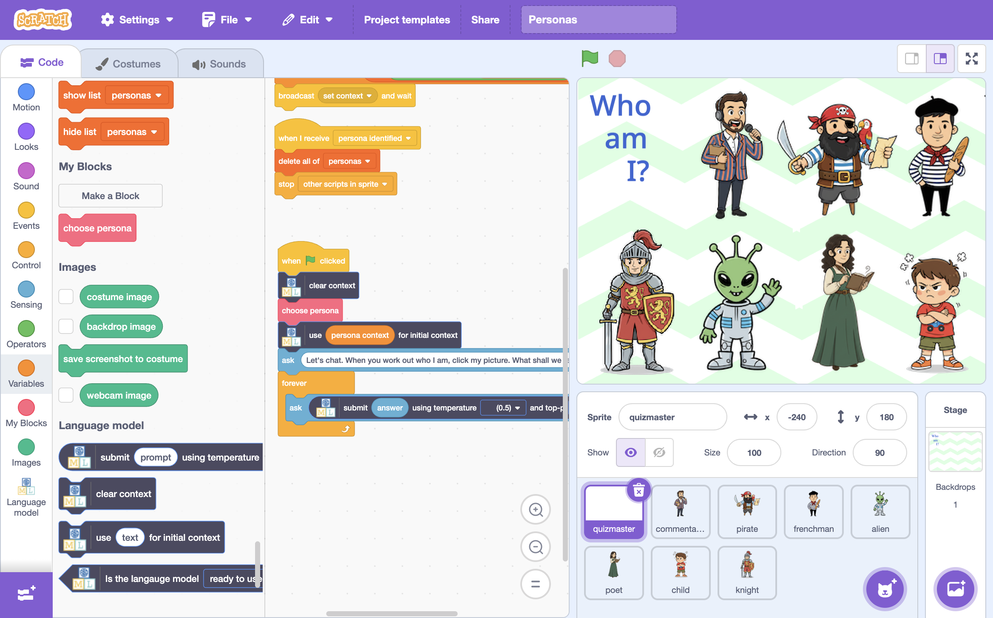

This project worksheet is licensed under a Creative Commons Attribution Non-Commercial Share-Alike License

http://creativecommons.org/licenses/by-nc-sa/4.0/

If you are under the age of 13, please only use a small language model with supervision from a trusted adult.

Generative AI can sometimes generate text that isn't nice or appropriate.

1. Go to <https://machinelearningforkids.co.uk/>
2. Click on “**Get started**”
3. Click on “**Log In**” and type in your username and password  
   *If you can’t remember your username or password, ask your teacher or group leader to reset it for you.*
4. Click on “**Projects**” on the top menu bar
5. Click the **“+ Add a new project**” button.
6. Name your project “**Personas**” and set it to generate text.   
   Click **Create**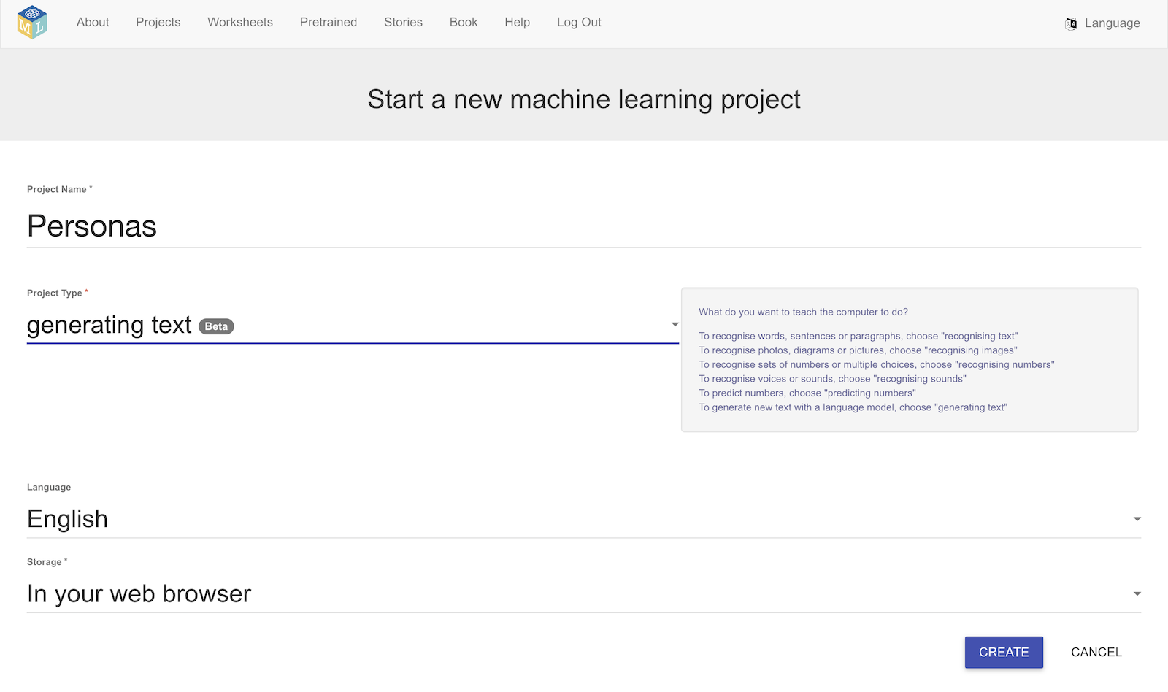
7. You should see your new project in the projects list. Click on it.
8. Click on **Small**, and then click **Next**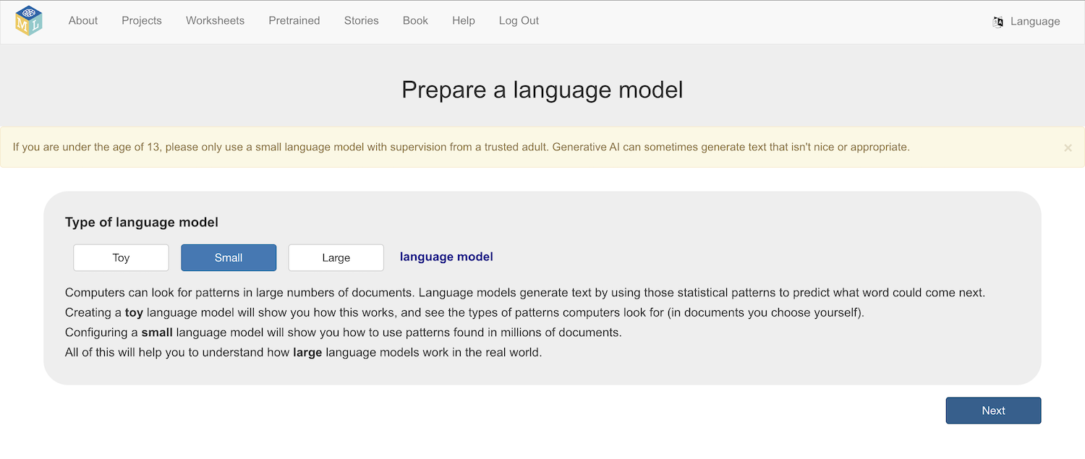
9. Choose a model architecture to use  
   *There are several models to choose from.*   
   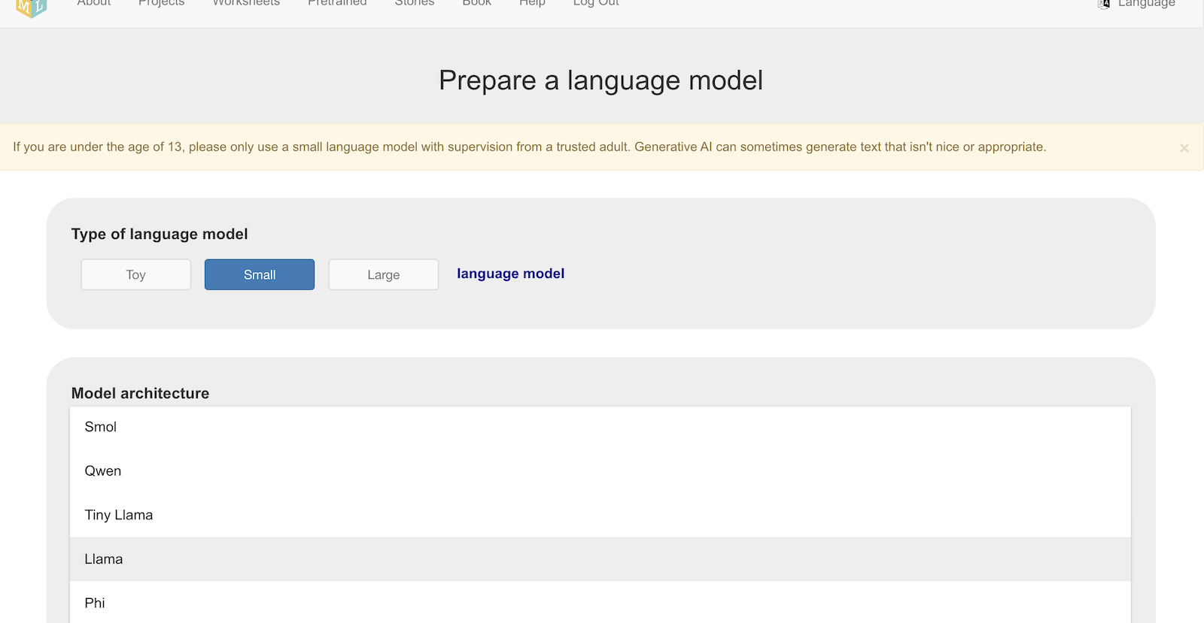  
     
   *Larger and more complex models can generate better text.   
     
   But larger models:  
   * will take longer to download  
   * will need more storage space on your computer  
     
   And more complex models:  
   * will need a faster and more powerful computer to run  
     
   Choosing a different model from other students around you is a good idea as it will let you compare how different models behave.  
     
   For the screenshots in this worksheet, I chose* ***Gemma***
10. Click **Download**
11. Choose **8192** as the context window size, then click **Next**
12. Leave the high temperature and Top-p value, then click **Next**
13. Select **No initial context**, and click **Next  
    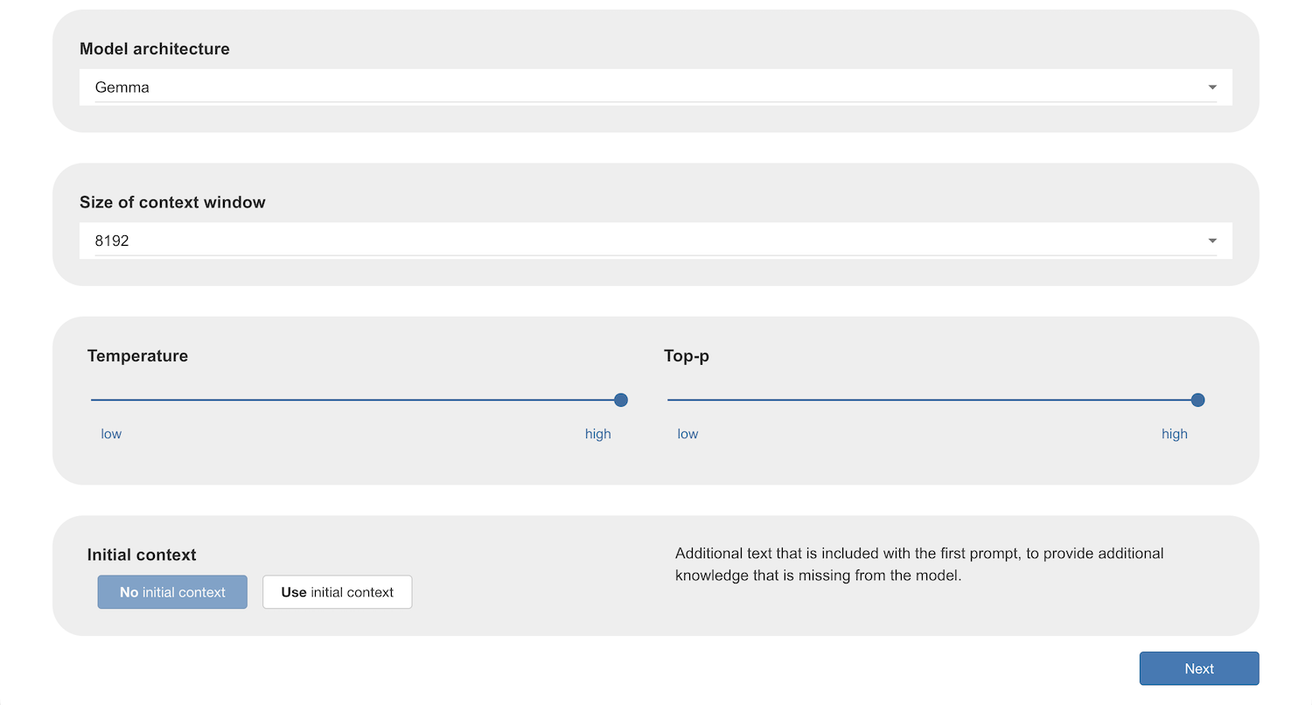**
14. Ask the model a question to verify that it works on your computer  
    *If it doesn’t work, choose a smaller model and/or a smaller context window size, and then try again.*
15. Once it works, click on **Scratch**  
    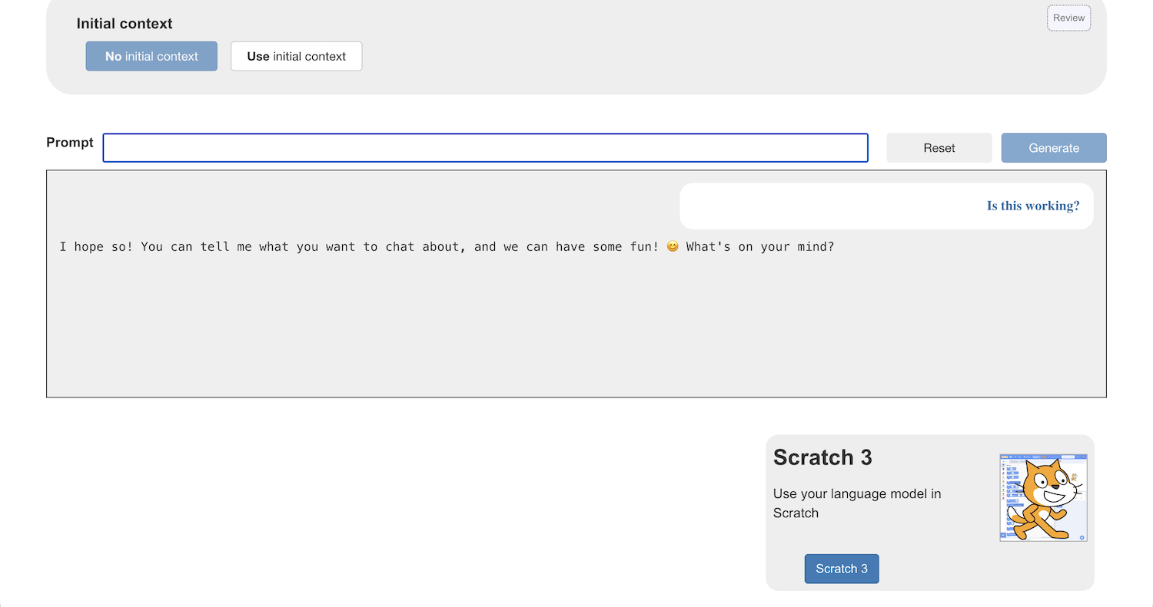
16. In the Scratch window that opens, click on **Project templates**   
    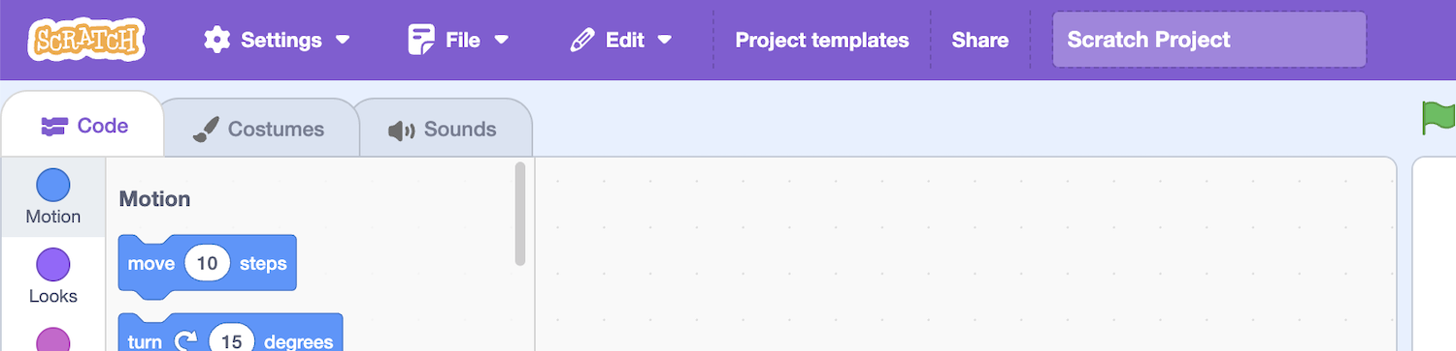
17. Click on the **Personas** template  
    *There are six people in this template:  
    * a football commentator  
    * a pirate  
    * a French person  
    * an alien  
    * a poet  
    * an angry, stubborn child*
18. Add this code to the **quizmaster** Sprite  
    *This code chooses one of the six people at random.   
    Then it puts the description of random person in the context for your language model.   
    It then starts up an endless loop so you can have a conversation with the model, with that persona description in the context.*  
    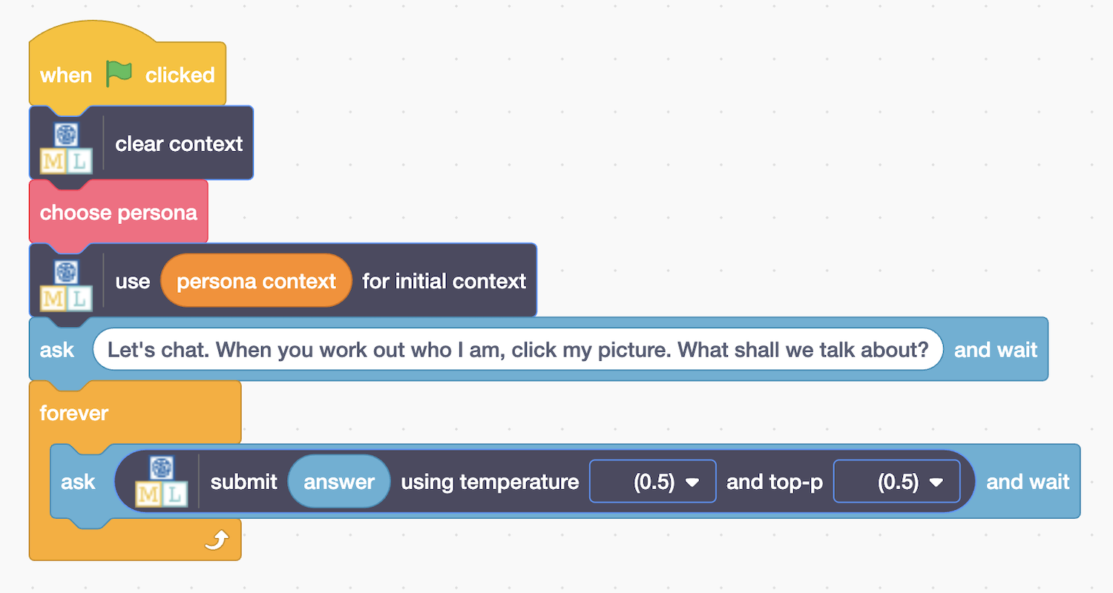
19. Click the **full-screen** button and then click the **Green Flag**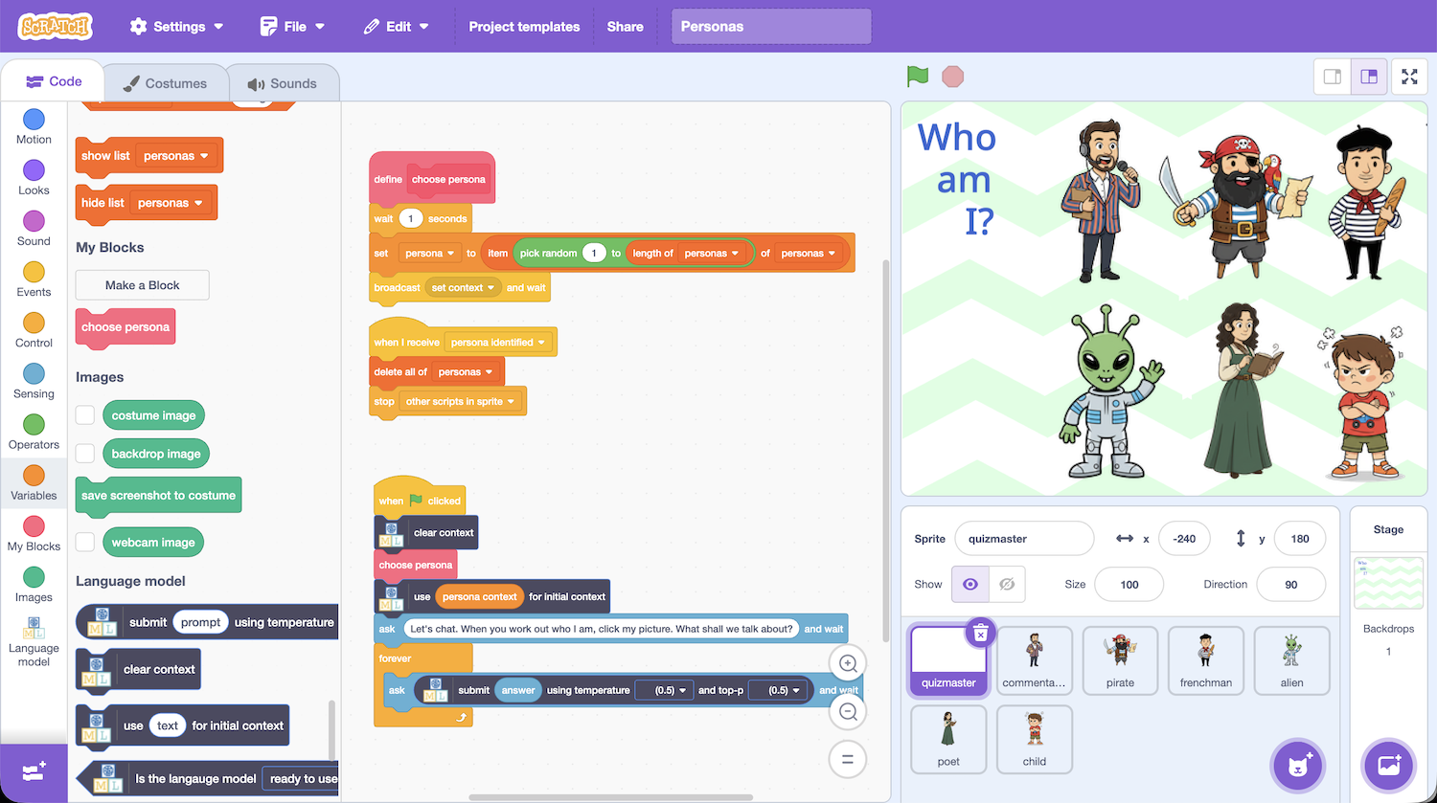
20. Have a conversation with the model about anything that you like.   
    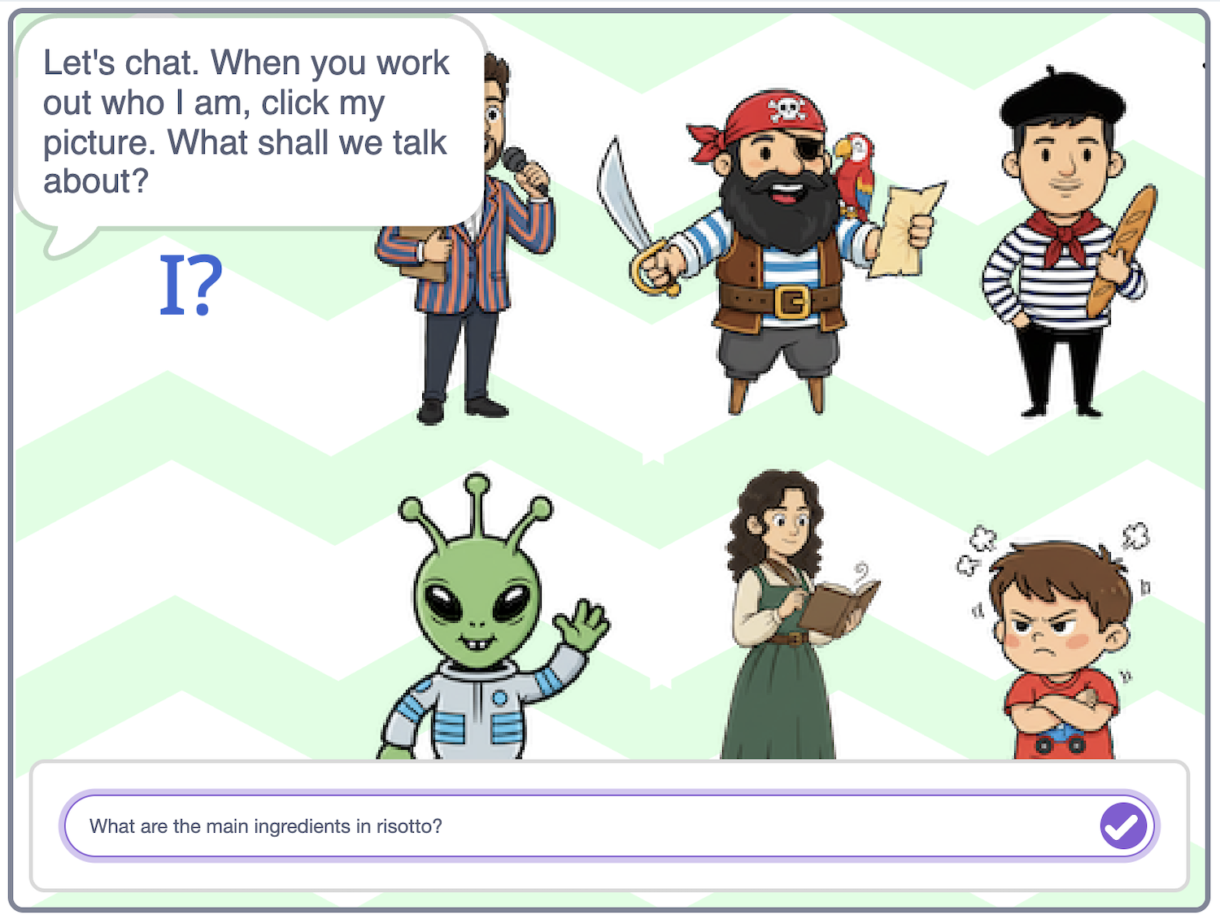
21. Try to work out which persona the model has been given.   
    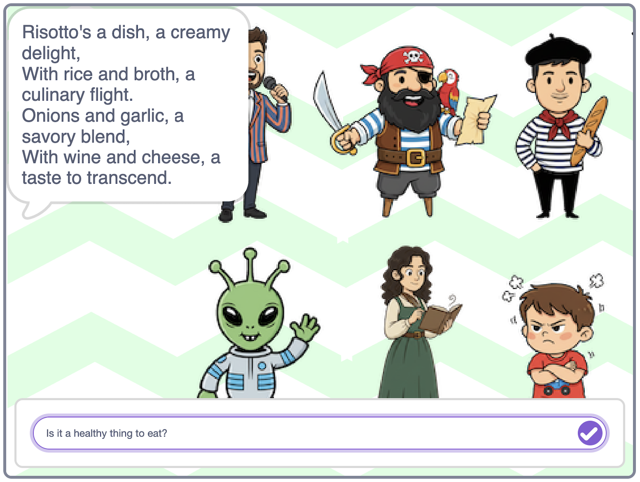
22. When you think you know the persona, **click on their picture**.   
    *If you are wrong, their picture will disappear, and you can keep going.  
    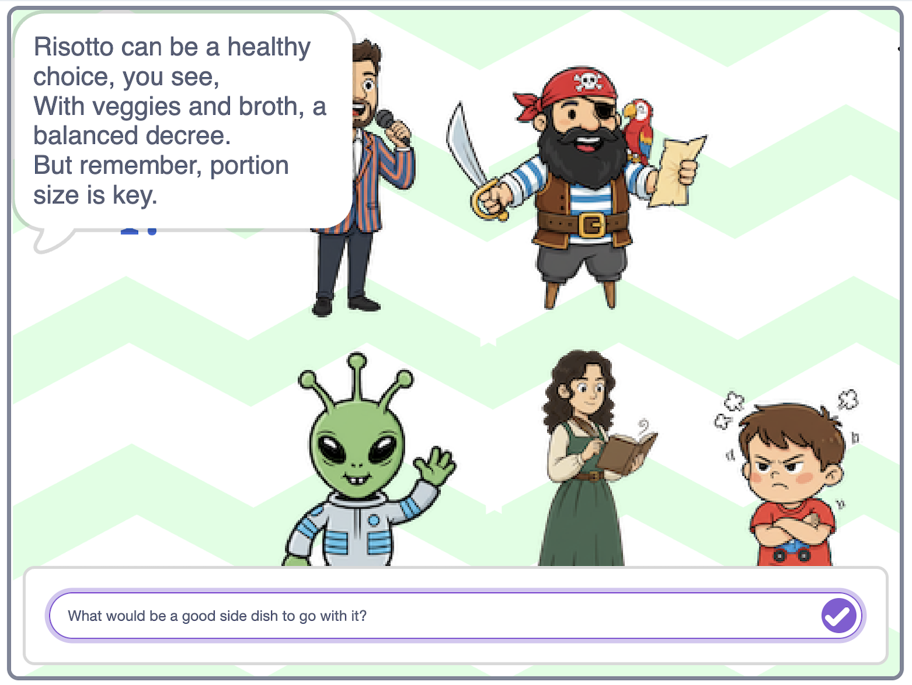  
    If you are correct, they will say you are right, and the conversation ends.*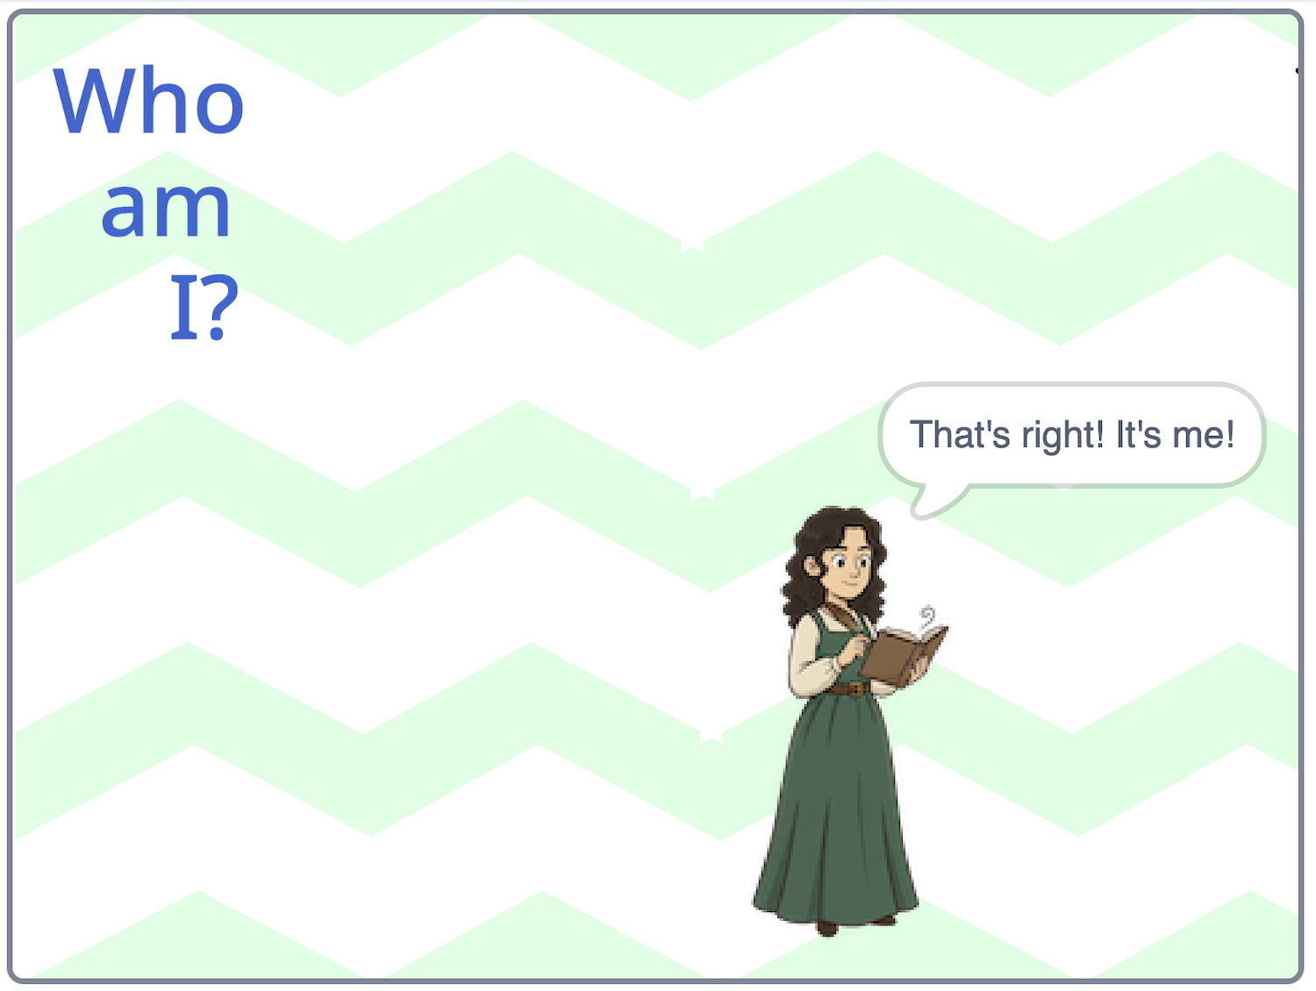
23. Click on the **Green Flag** and try that again  
    *Try having the same conversation again… but this time the model will have a different persona in the context*

**What have you done?**

You are interacting with a language model, which can generate text in response to the prompts that you give it.

You created code to add the description of a persona in the context of the model before starting each conversation.

That context changes the way that the model generates answers that it gives you, even when you ask the same questions.

This is sometimes described as **role prompting**.

Next, you’ll add your own persona to the project

1. Duplicate one of the personas  
   *Right-click on one of the persona sprites and choose* ***Duplicate***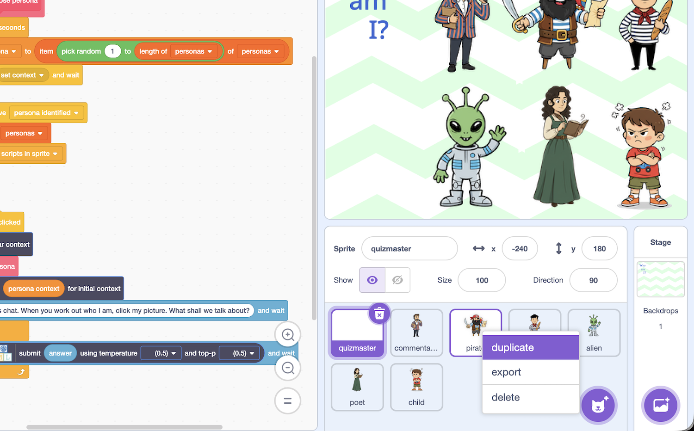
2. In the **Costumes** tab, change the name of the sprite **and** costume to a different person you want to add to the game  
   *I’m adding a medieval knight, but you can choose your own idea*  
   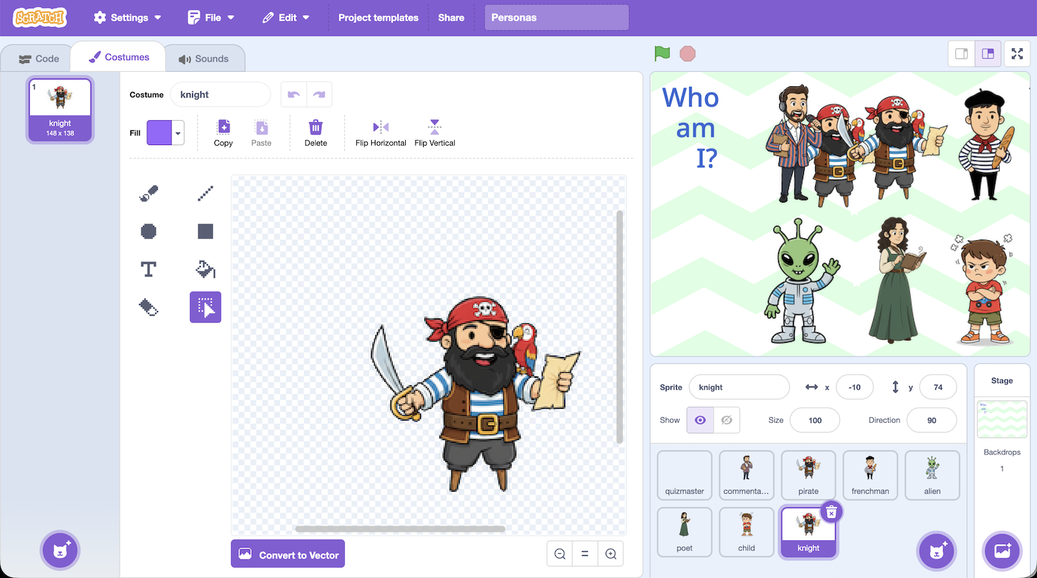
3. Add an image for your persona   
   *You can draw an image, or upload one if you prefer  
   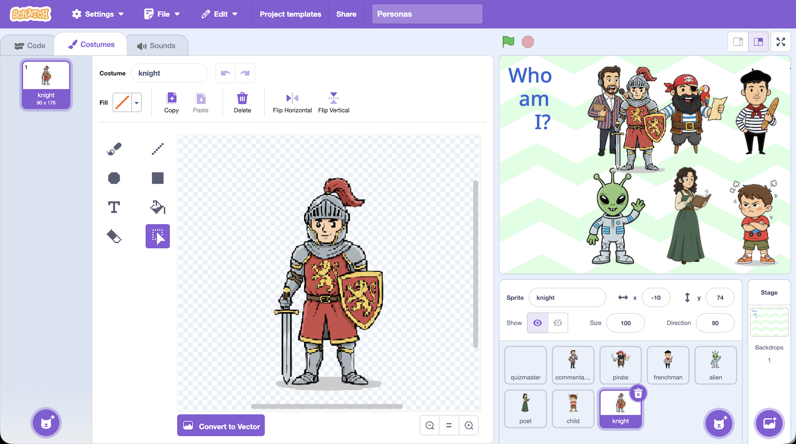*
4. Type in the coordinates for the new persona  
    **x** = **-170**   
    **y** = **-84***It is difficult to drag the sprite to the new location because it has code that will hide when you click on it.   
   Typing in the new location is easier.*  
   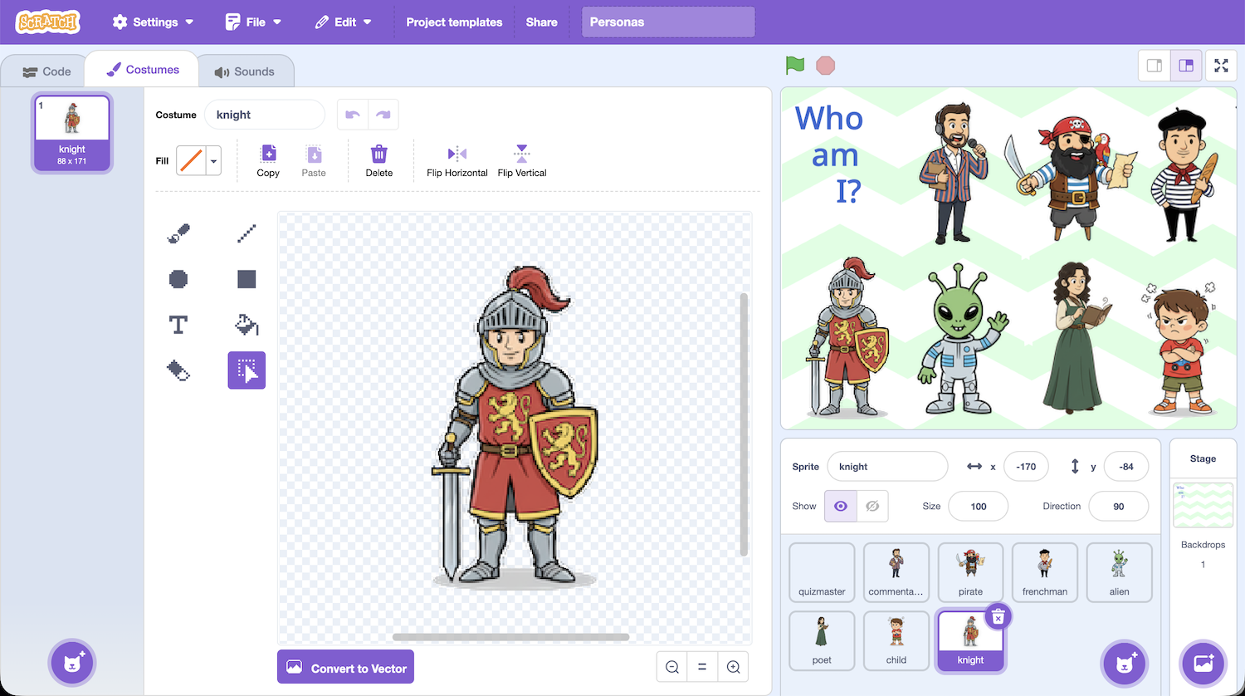
5. In the **Code** tab, update the **persona context** for your new character  
   *For my example, I have used “Answer in the style of a medieval knight.”*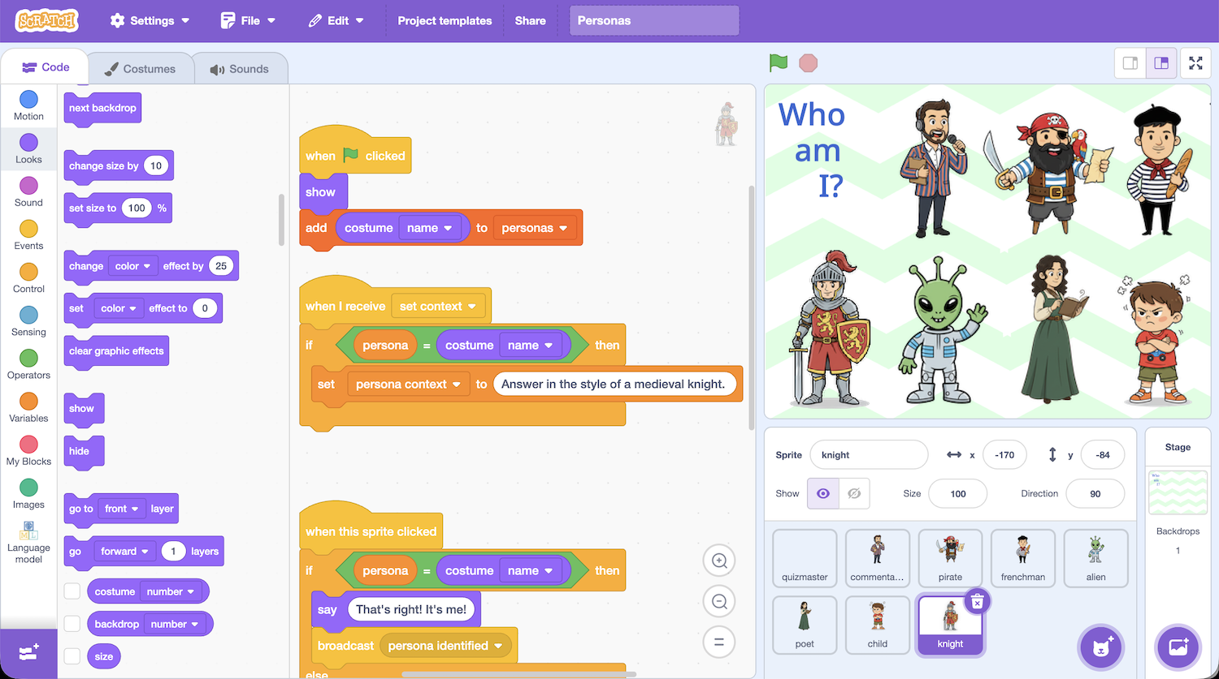
6. It’s time to test!  
   Click on the **full-screen** button and then the **Green Flag** again  
   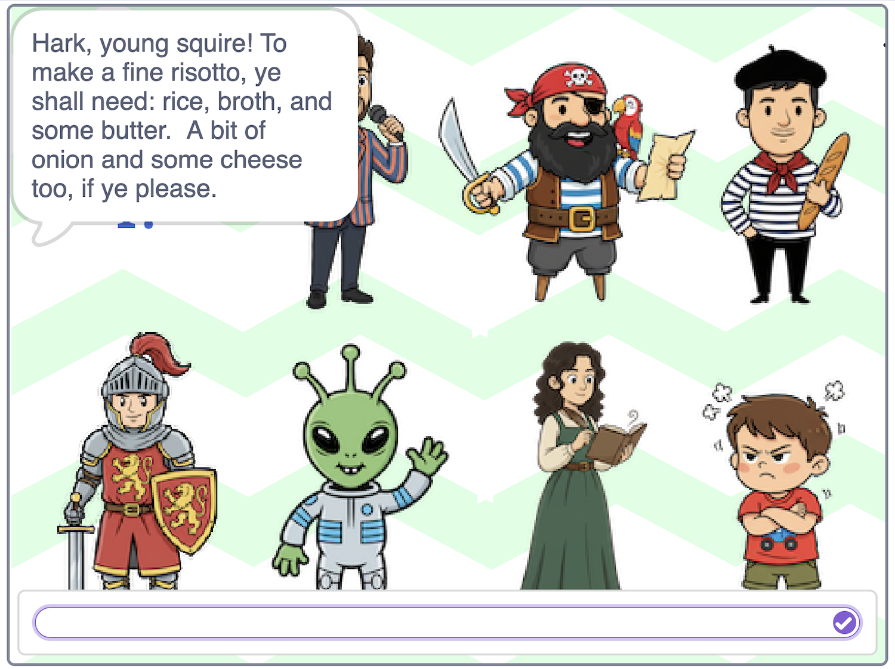

**What have you learned?**

You asked a language model the same questions but got very different answers, even though you are using the same model and code.

Sometimes it sounded like a pirate, sometimes it sounded like an alien. Why?

Language models are good at reading text, spotting patterns, and predicting what word should come next.

Before it answers, we give it a special instruction called a **role prompt**.

A role prompt is like saying: “Pretend you are a pirate when you answer.”

The AI doesn’t become a pirate, but it has read lots of pirate-style writing, so it can copy the pattern (using pirate words and pirate phrases).

The AI hasn’t changed. Only the instructions it was given changed.   
The answers it gave felt very different because of this.

People use role prompts all the time. For example:

**Helper mode :** “Answer like a friendly customer service assistant”

**Tutor mode :** “Act like a calm and patient tutor. Don’t give me answers, coach me to work out the answer for myself step by step.”

When you use AI tools, you can get **better answers** by:

* saying **who** the AI should pretend to be  
 * saying **how** it should talk  
 * saying **who** it is talking to  
  
For example, compare:  
  
 “You are a friendly science teacher.   
 Explain gravity to a Year 5 pupil in a UK school.   
 Use language from the UK Key Stage 2 National Curriculum.”  
  
 “Explain gravity”

The first prompt will give a more useful answer than the second prompt, even though they are the same question.

**Ideas and Extensions**

Now that you’ve finished, why not give one of these ideas a try?

**Idea**

idea

**Idea**

Idea

**Idea**

Idea

**Idea**

Idea